b

IDCF 2019 Intensified Diarrhoea Control Fortnight 28 May to 8 June 2019
  - OPERATIONAL GUIDELINES
Ministry of Health & Family Welfare,
Government of India
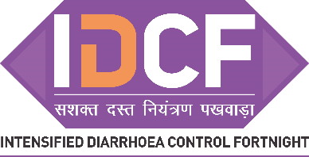
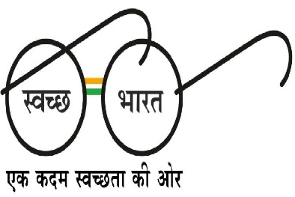
Intensification of efforts towards “zero” childhood deaths due to Diarrhoea across all States & UTs of India

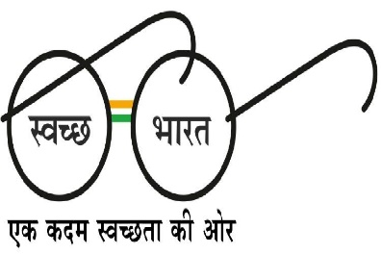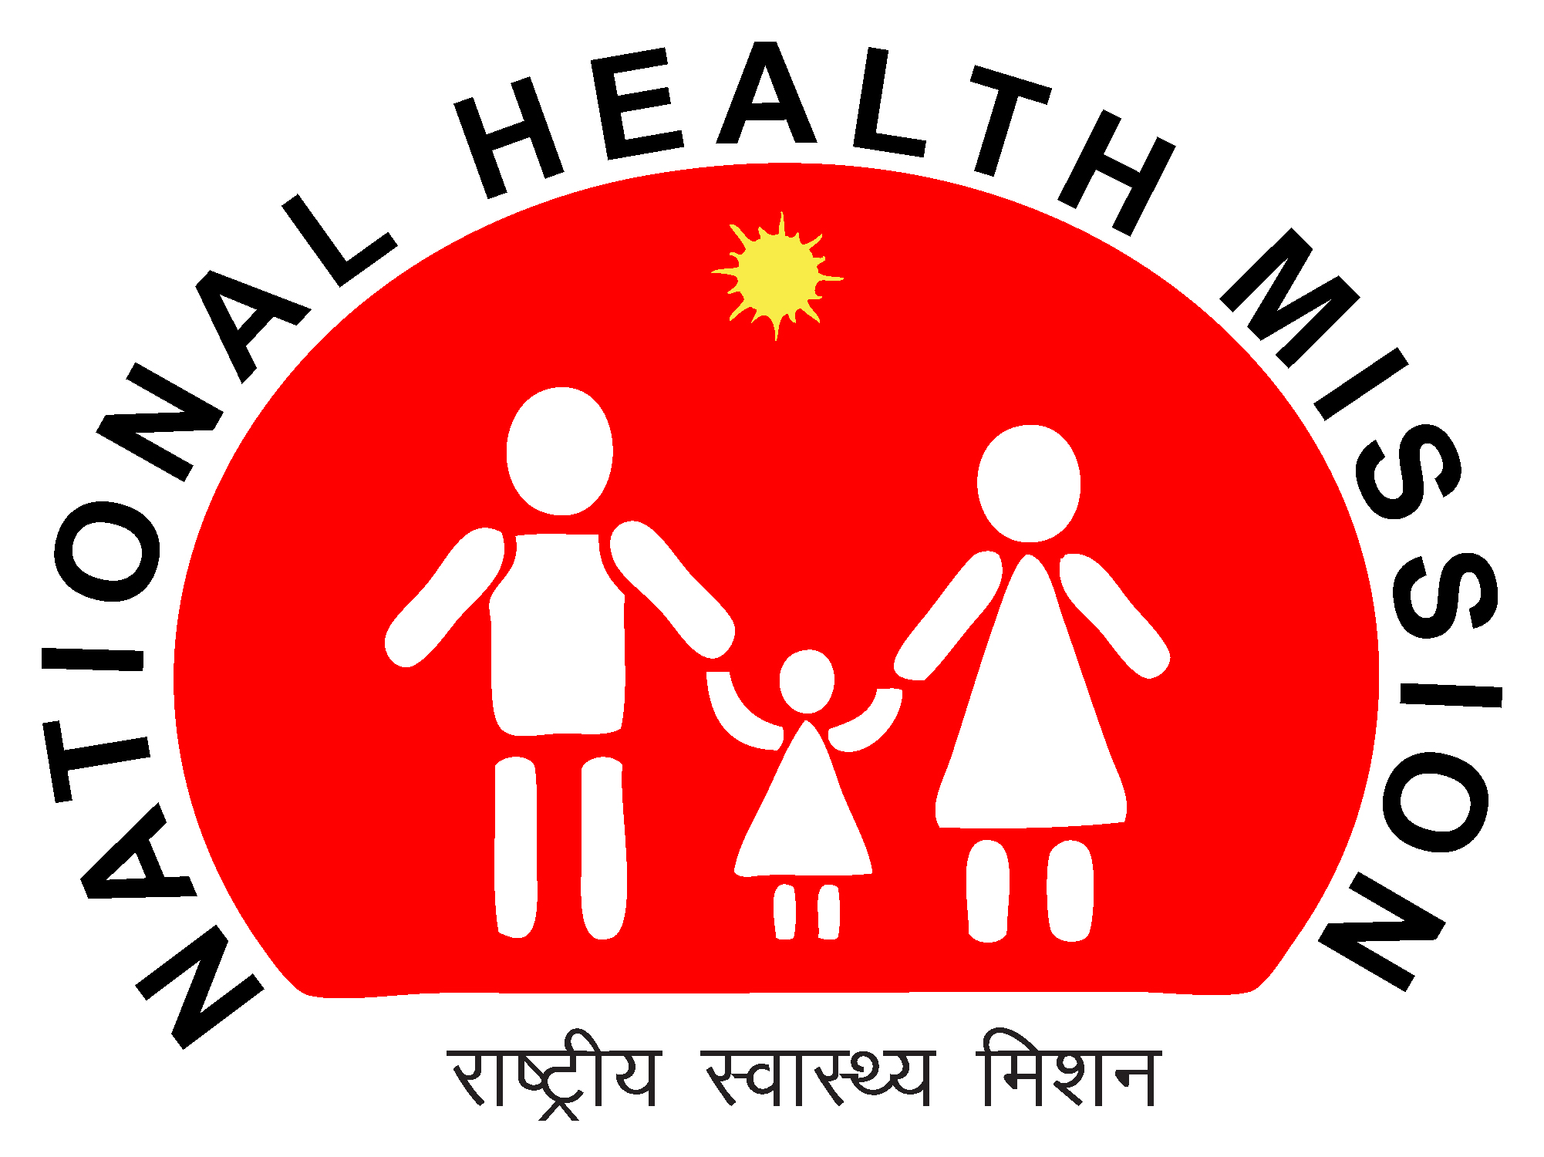
  - 4/3/2019

Contents
1. Introduction 1
2. Rationale 1
3. Objective and Strategy 2
3.1 Goal of IDCF 2
3.2 Objectives of IDCF 2
3.3 Strategy for the IDCF 2
4. Overview of activities in IDCF – 2019 (28 May to 8 June) 2
5. Pre- campaign planning 3
5.1 Setting up of the committees 3
5.1.1 IDCF coordination committee 3
5.2 IDCF orientation 4
5.3 Need assessment and planning for the supplies and logistic 5
5.4 Strengthen and gear up facilities for the IDCF 7
5. 5 Planning for IEC communication activities for the fortnight 7
5. 6 Formats to be used for planning the above activities for IDCF: 7
6. IDCF Campaign 7
6.1 Target beneficiaries 7
6.2 Priority populations 8
7. Detail of activities during IDCF 2019 8
7.1 At the community / village level 8
7.1.1 Distribution of ORS and demonstration of ORS and Zinc at the community level 8
7.1.2 Interpersonal activities by ANM on sanitation & hygiene along with management of diarrhoea. 9
7.1.3 Hand-washing demonstration in schools 10
7.2 At the facility level 10
7.2.1 Establishment of ORS- Zinc corners for treatment of diarrhoea: 10
7.2.2 Promote standard case management of diarrhoeal cases 11
7.3 Intensive Awareness generation 12
7.3.1 State level Launch: 12
7.3.2 District level launch: 12
7.3.3 Media and mid-media campaign: 12
7.3.4 Matrix of IEC activities: 12
7.4 Multi-sectoral involvement 13
Key messages for awareness generation to be used during IDCF 15
8. Supportive supervision and monitoring 16
8.1 State level monitors: 17
8.2 District level monitors: 18
9. Reporting 18
10. Financial guidelines 19
11. District Operational Plan/Timelines 17
Annexure I: Prevalence of childhood diarrhoea and coverage of ORS & Zinc in States & UTs as per NFHS 4, 2015-16 21
Annexure II. Agenda for the IDCF planning meeting 22
Annexure III: State operational plan - IDCF 2019 23
Annexure IV: District operational plan - IDCF 2019 28
Annexure V: Block operational plan - IDCF 2019 34
Annexure VI: Village level plan for IDCF and implementation checklist 38
Annexure VII: Village level plan cum monitoring format for IDCF and implementation checklist 39
Annexure VIII: Mobile team plan and reportingfor IDCF 40
Annexure IX: Sub-centre reporting format 41
Annexure X: Block reporting format 42
Annexure XI: District and State reporting format 43
Annexure XII: District level Supportive Supervision Checklist 45
Annexure XIII: Block / urban level Supportive Supervision Checklist 46
Annexure XIV: Village level Supportive Supervision Checklist 48
Annexure XV: Set up of ORS – ZINC CORNER 50
Annexure XVI: Mother and Child Protection Card – Diarrhoea prevention and treatment section 52
Annexure XVII: Content for VHSNC meeting to be conducted during IDCF. 53

Introduction
Reduction of childhood mortality from 39 / 1000 live births in 2016 to 23 by 2025 is one of the prime goals of National Health Policy 2019. Childhood diarrhoeal diseases continue to be a major killer among under-five children in many states, contributing to 10 percent of under-five deaths in the country. Around 1 lakh children die due to diarrhoea annually in the country. Diarrhoeal deaths are usually clustered in summer and monsoon months and the worst affected are children from poor socio-economic situations.
Diarrhoea is considered when the stools have changed from usual pattern with increase in frequency and change in consistency (more water than faecal matter). Almost all the deaths due to diarrhoea can be averted by preventing and treating dehydration by the use of ORS (Oral Rehydration Solution) and administration of Zinc tablets along with adequate nutritional intake by the child during diarrhoea. Diarrhoea can be prevented by exclusive and continued breastfeeding, timely introduction of appropriate and safe complementary feeding, use of safe drinking water, hand-washing, sanitation and immunization.
The effect of diarrhoeal mortality remains high in children and hence in continuation of the efforts in 2014 to 2018, it has been decided to organise an Intensified Diarrhoea Control Fortnight (IDCF) this year from 28 May to 8 June2019, with the ultimate aim of ‘zero child deaths due to childhood diarrhoea’.
Intensified Diarrhoea Control Fortnight (IDCF) consist of a set of activities to be implemented in an intensified manner from 28 May to 8 June2019 for prevention and control of deaths due to dehydration from diarrhoea across all States & UTs. These activities mainly include- intensification of advocacy & awareness generation activities for diarrhoea management, strengthening service provision for diarrhoea case management, establishment of ORS-Zinc corners, prepositioning of ORS by ASHA in households with under-five children and awareness generation activities for hygiene and sanitation.

Rationale
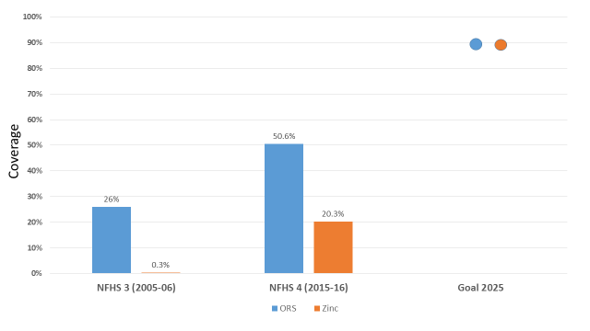
The diarrhoeal mortality in India still remains unacceptably high in under-five children. Timely and appropriate treatment by ORS and Zinc can save many lives. At the national level, ORS coverage improved from 26 percent to 50.6 percent and Zinc coverage from 0.3 percent to 20.3 percent from 2005-06 to 2015-16. However, the coverage of both ORS and Zinc needs to reach the target of 90 percent by 2025 as per the India Action Plan for Pneumonia and Diarrhoea (IAPPD).
Coverage of ORS and Zinc and target

For ready reference of the states / UTs, the prevalence of childhood diarrhoea and coverage of ORS & Zinc as per NFHS 4, 2015-16 is given in annexure 1. The ORS and Zinc use rate still remains low in many states and districts. To address this issue, the Ministry of Health and Family Welfare in close collaboration with state / UT governments has been implementing IDCF every year since 2014. The IDCF in 2019, will be implemented from 28 May to 8 June.

Objective and Strategy

3.1 Goal of IDCF
The ultimate goal is to reach zero child deaths due to diarrhoea.

3.2 Objectives of IDCF
The IDCF is a preparatory activity to address potentially high incidence of diarrhoea during the summer/monsoon season and floods / natural calamity.
The objectives of IDCF are:
- To ensure high coverage of ORS and Zinc use rates in children with diarrhoea throughout the country
- Inculcating appropriate behaviour in care givers for diarrhoea prevention & management of under-five children,
Special focus needs to be accorded to the high priority areas and vulnerable communities.

3.3 Strategy for the IDCF
The focus of IDCF is on delivery of simple proven interventions that have large impact towards control of childhood diarrhoeal morbidity and mortality. The IDCF strategy is three folds, as below:
- Improved availability and use of ORS and Zinc at households
- Facility level strengthening to manage cases of dehydration
- Enhanced advocacy and communication on prevention and control of diarrhoea through IEC campaign.

Overview of activities in IDCF –2019 (28 May to 8 June)
- At community / village level
  - Distribution of ORS to households (pre-positioning) and demonstration of preparation of ORS &Zinc
  - IPC activities by ANM on diarrhoea prevention and management during VHSND
  - Handwashing demonstration in schools, out-reach sessions, VHNSDs and AWCs
  - Mobile health teams for urban areas and hard to reach terrains for intensified diarrhoea control activities

- At health facility level
  - Establishment of ORS and Zinc corners for treatment of diarrhoea
  - Promote standard case management of diarrhoeal cases through capacity building and display of treatment protocols
  - Cleaning of water tanks in health facilities

The states may prioritise to conduct school level activities (hand washing demonstration) in the initial days of the campaign if IDCF campaign is clashing with school holidays.
The state and municipalities may link / merge their diarrhoea control activities with IDCF. These activities could be distribution of Chlorine tablets to households, cleaning and disinfection of wells etc

Pre- campaign planning

5.1 Setting up of the committees

5.1.1 IDCF coordination committee
Central IDCF coordination committee has been established at the MoHFW, Government of India to oversee the implementation of this fortnight. Similar committee should be established at State and District level.

At the State level, Principal Secretary Health or MD – NHM should lead the IDCF Steering Committee with support of key staff from Directorate of Health and Family Welfare.

At the District level IDCF committee should be formed, led by District Magistrate and with support from Chief Medical and Health Officer of the district. At both the State and District level, Program Officer for Child Health should be the member secretary. IEC Officer should also be in the Committee.

- 5.1.1a IDCF Steering Committee meeting: The lead official from State and District shall call a meeting of the Committee before, during and after the fortnight to ensure effective implementation of the IDCF.
  - Departments to be invited for the meeting: Health and Family Welfare, State Health Resource Centre / ASHA Resource Centre, Department of Women and Child Development, Dept. of Panchayati Raj, Dept. of Water and Sanitation, Dept. of HRD / Education, Dept. of Tribal Welfare, Dept. of Social justice and Backward and Minority affairs /Municipalities, State / District IEC Department / Publication Bureau, Song and Drama division etc.

  - Partners to be invited for the meeting: IAP, IMA, UNICEF, WHO, CHAI, Nutrition International, Save the Children, JSI, other local partners at the State / District. To improve the support to States, it is proposed that Development Partners may work closely with the State Governments during the State level briefing of Districts partners to support respective state to plan, build capacity and monitor activities for the fortnight.

- 5.1.1b Orientation of district level officials: Continuous efforts of orientation of district officials through meetings or video conference should to be conducted by State NHM to sensitize for planning of IDCF. Annexure-II provides suggested agenda items to be covered during meeting/ VCs.

5.2IDCF orientation
One day orientation workshops of various categories of stakeholders need to be carried out.
Location | Participants | Contents of orientation | Timeline
State/Regional level | RDD, CS, DIO, RPM, DPM, DCM, DSO, PO – ICDS | Managerial aspects of IDCF and planning, monitoring and IEC of IDCF. | By 16th April 2019
District level | BPO/ MOs / BCM / BCPM/ BHMetc. |  | By 16th April 2019
Block/PHC level | Medical Officer, AYUSH Medical Officer, Nursing staff, ANM, ASHA& AWW | Technical orientation on diarrhoea management along with programme orientation of IDCF which involves their roles and activities during IDCF. | By 30thApril 2019
Important Note: The orientation should focus on explanation on distribution of ORS, management of diarrhoea, supportive supervision formats and IEC material and plan of activities to all frontline workers. Module for technical orientation on childhood diarrhoea control is available in IDCF toolkit

5.3 Need assessment and planning for the supplies and logistic
Special attention to availability of supplies and logistics for the campaign is critical to achieve high coverage. It is important to forecast procurement well in advance and to plan for distribution of ORS and Zinc supplies.
District requirement:
On an average, one under-five child suffers from 1.6 episodes of diarrhoea per year. Each episode requires ORS and Zinc treatment. Each episode of diarrhoea will require on an average 2 packets of ORS and 14 tablets of Zinc. This should be taken into account for calculating annual requirement for the District for regular supply.

For the purpose of IDCF the calculation of requirement is as follows for a district of 20 lakh population.

Total under five children:2 lakh

Total number of households in the district: Total population/ 5 (average family size) = 4 lakhs

Number of ORS – Zinc corners:
Total OPDs and pediatric wards of medical colleges, district hospitals, CHCs, PHCs, subcentres = 500

Requirement for IDCF for a district of 20 lakh population

IDCF activities | Quantity
Pre-positioning of ORS
ORS for pre-positioning in households by ASHA and mobile teams | 2 lakh X 1 packet = 200,000 packets
Demonistration of ORS and Zinc in VHND by ASHA and mobile team
ORS for demonstration in community | 4,000 packets
Zinc for demonstration in community | 4,000 tablets
Treatment of childhood diarrhoea cases
ORS for ORS – Zinc corners | 500 corners X 50 cases X 2 packets = 50,000 packets
Zinc for ORS – Zinc corners | 500 corners X 50 cases X 14 tablets = 350,000 tablets
ORS for ANM | 400 ANMs X 10 cases X 2 packets = 8,000 packets
Zinc for ANM | 400 ANMs X 10 cases X 14 tablets = 56,000 tablets
ORS for ASHA | 2000 ASHA X 10 cases X 2 packets = 40,000 packets
Zinc for ASHA | 2000 ANMs X 10 cases X 14 tablets = 280,000 tablets
ORS for mobile team | 10 teams X 10 cases X 15 days X 2 packets = 3,000 packets
Zinc for mobile team | 10 teams X 10 cases X 15 days X 14 tablets = 21,000 tablets
So, ORS = 305,000 packets and Zinc tablets = 711,000

For treatment of diarrhoea cases, at any given time a minimum of 20 ORS packets and 140 Zinc tablets should be made available with each ASHA and ANM througout the year
State forecast should be based on cumulative demand of each district in the state.
In case sufficient stocks are not avaibale, the District or State should undertake procurement of ORS and Zinc on an urgent basis, but as per rate Contracts from qualified vendors, maintaining quality of supplies.

5.4Strengthen and gear up facilities for the IDCF
- Health Facilities to be equipped to provide both OPD and inpatient diarrhoea management.
  - Establishing ORS – Zinc corners for ambulatory care for some dehydration
  - Inpatient care for severe dehydration in diarrhoeal cases
  - Ensure standard treatment protocols for management are available at all facilities
- Cleaning of water tanks in health facilities and overall sanitation and hygiene to be undertaken.
- Schools should be geared up for hand washing demonstration.

5. 5 Planning for IEC communication activities for the fortnight
The District IDCF committee would undertake:
- Assessment of available IEC materials such as videos, hoardings, posters, pamphlets for display at ORS – Zinc Corners and placement at strategic locations, prior to the Fortnight.
- Prototypes of additional IEC material are available on the website www.nrhm.gov.in.States are encouraged to use these materials widely for the IDCF campaign. If necessary, adaptation and translation/dubbing in regional language may be carried out at the local level for better awareness generation in the communities.
- Any other media and mid-media planning for reinforcement of messages on diarrhoea prevention and control may be used.

5. 6Formats to be used for planning the above activities for IDCF:
1. State operational plan (Annexure III)
2. District operational plan (Annexure IV)
3. Block operational plan (Annexure V)

IDCF Campaign

6.1 Target beneficiaries
The target beneficiaries for the campaign include:
- All under-five children including their care-givers/mothers for community mobilization*(for pre-positioning ORS / Zinc)
- Under 5 years children suffering from diarrhoea (for treating diarrhoea)
*However, for involvement of this core audience, a large number of secondary audiences that influences them should be involved such as School teachers/children, PRI members, Health & ICDS functionaries, private practitioners etc.

6.2Priority populations
IDCF is a nationwide drive; however the focus should be to reach the underserved and vulnerable communities.Key locationsto reach through ICDF should include:
- Areas with where sub-centres have no ANM: ANM not posted / or on long leave for more thanthree months
- Within villages houses that are located in or near unsanitary conditions.
- High risk areas (HRAs) with populations living in areas such as:
  - Urban slums
  - Underserved and hard to reach populations (forested and tribal populations, hillyareas etc.).
  - Flood prone areas
- Migrant settlements (fisherman villages, riverine areas with shifting populations, refugees)
- Nomadic sites
- Brick kilns
- Construction sites
- Orphanage
- Temporary shelters
- Street children
- Areas known for or with diarrhoeal outbreaks, in last two years.
- Areas known for poor sanitation and water supply.
- Small villages, hamlets, dhanis, purbas, basas (field huts), etc.

Micro-plans at the village level to be compiled by ANMs / supervisor, block level by Medical Officer Incharge and at District level by CMO. Template for the micro-plan is annexed(AnnexureVI,VII)

Detail of activities during IDCF 2019
The states may prioritise to conduct school level activities (handwashing demonstration) in the initial days of the campaign if IDCF campaign is clashing with school holidays.
The following activities to be undertaken during the fortnight:

7.1 At the community / village level

7.1.1 Distribution of ORS and demonstration of ORS and Zinc at the community level
- Every ASHA to distribute ORS packets to all families with under five children.
- During the household visit ASHA will deliver key messages to the mothers / families (Key messages in box on Page 15). The MCP card will be used as a counselling tool(Annexure XVI).
- A group demonstration for the preparation of the ORS solution will be conducted by ASHA. It will involve gathering of members from 4-8 households and demonstrating the steps for preparation of ORS solution and Zinc solution. Understanding of the caregivers must be checked after the demonstration. (how to prepare it is in tool kit)
- ASHAs will also educate families on the importance of hygiene and sanitation.
- ASHA will undertake identification and referral of diarrhoeal cases to ANM/ health facilities and also educate mothers on the danger signs.
- ASHA will report all diarrhoeal deaths during the fortnight.
- At the end of Fortnight a report will be submitted by ASHA→ANM→BCM (Block DEO will compile the data)→ DCM (DM&E will compile the data)→State Health Society.
- The activity of the village to be monitored by ANMs
Note: ASHA should distribute her workload in such a way that she covers all the households of under-five children in 15days (Usually ASHA covers it in one week). On an average there will be 100-130 under-five children in a village, so the ASHA will visit 10 under-five children in a day that implies 4-8 households. Every ASHA would be provided an incentive of Rs. 1 per ORS packet distributed to a family with under five children.
Community level activities provide the last mile connectivity and complete execution of the campaign and hence must be implemented effectively.

7.1.2 Interpersonal activities by ANM on sanitation & hygiene along with management of diarrhoea.
- During the fortnight, ANM should conduct IDCF meeting in her Sub centre village and VHNSDs (as per her existing micro-plan)to disseminate information on prevention & control of diarrhoea, especially involving care givers of under-five children.
- ANM should start the session with key message of the IDCF campaign highlighting importance of ORS and Zinc, continued feeding, hand-washing in control of childhood diarrhoea and use of toilets for defecation.The MCP card will be used as a counselling tool (Annexure XVI).
- ANM should carry out Participatory learning technique on sanitation & hygiene, as per Annexure XVII. Active participation of Department of Water and Sanitation at States/District level should be taken to carry out this activity.
- All frontline functionaries should target out-reach sessions, VHNSD etc to optimise the campaign

7.1.3 Hand-washing demonstration in schools
- This activity needs to be carried out in all primary and middle schools.
- Each school should have poster pasted at the hand washing area on steps for effective hand washing.
- After the morning assembly / prayers, message on importance of hand washing should be delivered to all the students.
- Before mid-day-meal, all children should be taught to wash hands with water and soap following the steps in the poster.
- Prabhat pheri or rally by school children on topic of hand-washing to be carried out.
7.1.4 Mobile health teams for urban areas to cover children in urban slums, migrant population, street children, juvenile homes, orphanages etc.
- Mobile teams should be formed, with the cooperation from Municipalities, for visiting slums, floating population etc.
- There should be high visibility of activities through posters, banners, FM radio.
- Urban ASHA (USHA), wherever available will work as outlined for rural ASHA.

7.2 At the facility level

7.2.1 Establishment of ORS- Zinc corners for treatment of diarrhoea:
- ORS- Zinc corner should be established for the treatment of diarrhoea preferably in an easily noticeable area near the entrance of following facilities and in paediatric ward if available:
  - Medical Colleges
  - District Hospital
  - Block CHC / PHC
  - Subcentre
  - Anganwadi centres
  - Urban health posts / health centres
  - Private medical practitioners
The private paediatricians / medical practitioners through IAP / IMA should be encouraged for setting up of ORS – Zinc corners in their clinics and wards.
iii. In order to establish ORS- Zinc corner, refer to Annexure XV.
- During the IDCF and beyond, all facilities should have sufficient availability of ORS and Zinc dispersible tablets.
- Tertiary level facilities with Nutritional Rehabilitation Centres must be geared up for management of SAM children with diarrhoea as per GoI NRC guidelines.
- Arrange management of severely dehydrated cases as per IMNCI Plan C.
- Paste and display facility appropriate treatment protocols in OPD and paediatric ward/General IPD (refer toolkit).
- Promote prescription of ORS along with Zinc dispersible tablets for childhood diarrhoea by all healthcare providers.

7.2.2 Promote standard case management of diarrhoeal cases
The standard treatment protocol for management of childhood diarrhoea is as per Plan A,B, and C (refer to IDCF toolkit)
- Diarrhoea cases with no dehydration will be treated with ORS, extra oral fluids and Zinc as per IMNCI Plan A.
- Diarrhoea cases with some dehydration will be managed for rehydration with ORS under observation as per IMNCI Plan B; then shifted either to IMNCI Plan A to C.
- Diarrhoea cases with severe dehydration will be admitted and rehydrated with IV Ringer Lactate in wards (IMNCI Plan C), once rehydrated will shift to Plan A (ORS, extra oral fluids and Zinc).
- The above protocols is for treatment of all diarrhoea cases managed at both public and private health facilities routinely and during IDCF.
- Medical officers and nursing staff at health facilities to be oriented on the diarrhoea treatment plan.(Ref.-IDCF toolkit).
- Pasting and display of facility appropriate treatment protocols in OPD and paediatric ward/General IPD:
• Plan A, Plan B, and Plan B – SAM in OPD
• Plan A, Plan B, and Plan B – SAM, Plan C and Plan C-SAM in wards

Intensive Awareness generation

7.3.1 State level Launch: The IDCF should be launched by a Minister at State level and by elected representative/senior-most official at District and Sub District level. Raise visibility of the Fortnight by involving Chief Ministers/ Health Minister/ other ministers / MPs/MLAs/PRI members. CMs / HMs may be asked to lead the movement and address the public through media with the message that ‘No Child Should Die in the State due to Diarrhoea.’

7.3.2 District level launch: The Fortnight should be launched at District level by elected representative/senior-most official, which may be facilitated by IMA/IAP. The launch should be widely publicised.

7.3.3 Media and mid-media campaign: Awareness generation during fortnight using mass and mid media along with folk lore and other means of communication as per population needs should be undertaken in local language.
- Television and Radio should be utilised to increase reach of the messaging among the target audience as mid media and outreach provide depth to the messaging but have limited reach.
- Posters, banners, hoardings should be displayed at strategic locations.
- All the IEC materials and reporting formats should be available with the stake holders at least 3 days before the Fortnight, preferably distributed during orientation meeting.
- Such material has also been developed at National level and would need to be printed at State level and distributed to all health facilities. TV and Radio spots are available on MoHFW website http://nrhm.gov.in
7.3.4 Matrix of IEC activities:
 | IEC activity to be undertaken | Key person
State level | - T.V/ radio advertisements  - State level launch of IDCF by CM/ HM  - Support districts by providing IEC material prototypes shared by GoI  - Support districts by providing other printed material- orientation material, FAQs, IDCF guidelines, supportive supervision formats  - State level monitors to be sent to each district for observation and guidance of activities, especially to aspirational districts  - SMS delivery on diarrhoea control through MCTS. | MD(NRHM)
District Level | - IDCF Launch by elected representative/senior-most official, to be organised jointly by CMO office and Indian Medical Association/Indian Academy of Paediatrics  - Placing banners/posters at strategic locations | CMO
Schools /Colleges | - Organise WASH activities during the Fortnight in which soap, clean water is provided and hand-washing is observed before Mid-Day Meal / School lunch; Posters on Hand washing to be put in hand washing area  - Organise Elocution/painting competition on diarrhoea and use of ORS and Zinc followed by a lecture by BMO/MO on Diarrhoea and ORS and Zinc | BMO/Active MO of CHC,PHC
Block Level | - Special session on childhood diarrhoea- ORS/Zinc in meeting of Block PRI members (Funds from PRI system)  - Similar session in BDC meeting  - Daily miking for key messages  - Placing banners/posters at strategic locations | BMO/BHO
Village level | Wall painting in each village on use of ORS/zinc, WASH | PHC MO
Village level | Goshthi/village level discussion on Diarrhoea management (can utilize VHNSD platform) | ANM/ MO
Village level | Daily miking | PHC MO
Others | Messaging about ORS and Zinc through Munadis/Nukkad Natakas/ Folk lore | MO

It is advisable to utilize Mother and Child Protection Card (diarrhoea prevention and treatment) at each level, especially at inaugurations, special sessions and discussions on diarrhoea.

7.4 Multi-sectoral involvement
Multi-sectoral involvement is essential for activities that generate momentum and awareness such as carrying out rallies, competitions at Schools, conducting meetings with Panchayati Raj at District/Block level, awareness generation in remote areas by involving tribal department, State and District level launch by leaders, involvement of IAP/IMA, mother meetings and demonstrations at Anganwadi Centres.
- All linedepartments for launch activity: Departments such as WCD, Drinking Water and Sanitation, Rural Development, Panchayati Raj and Education along with IAP, development partners should be invited and commitment should be extracted for IDCF.
- Department of WCD, for establishing ORS-Zinc corners in AWCs: Instruction to be issued by the department to their staff informing the IDCF activities and their role. AWWs should make additional home visits for feeding management during diarrheal episode
- Education department, for handwashing demonstration and competitions at schools: Instruction to be issued by the department to their staff informing the IDCF activities and their role.
- Drinking water and sanitation / rural development department: Complement their activities with IDCF. These activities could be disinfection of wells / water sources, ODF sustainability with focus on toilet use etc.
- Panchayati Raj: For dissemination of key messages through Panchayati Raj Institution, block development meetings. For “Zero Tolerance of Childhood Deaths due to Diarrhoea” with aim of achieving a diarrhoea free gram panchayat.
- Involvement of Indian Academy of Paediatrics (IAP) / Indian Medical Association (IMA) / development partners/NGOs/CSOs: The various activities proposed are :
• Facilitating launch though State and District Health Mission
• Organising sensitisation meeting of their members, local Practitioners, Chemists regarding ORS and Zinc use and rational use of antibiotics in case of diarrhoea.

Key messages for awareness generation to be used during IDCF

To be used by all functionaries
- Give ORS and extra fluids to child immediately at the onset of diarrhoea and continue till diarrhoea stops.

  - Give Zinc for 14 days to children suffering from diarrhoea, even if diarrhoea stops.

  - Use of ORS and Zinc during diarrhoeal episodes among children is a safe treatment andhelps the child recover faster from diarrhoea.

  - Continue feeding, including breastfeeding in those children who are being breastfed & give extra feeds during and after illness.

  - Use clean drinking water after safe handling.

  - Safe and quick disposal of child’s faeces.

  - Mother should wash her hands with soap before preparation of food, before feeding the child and after cleaning stool of child.

  - Return to the health worker / centre if the child develops the following during treatment:

  - Childbecomessicker
  - Notabletodrinkorbreastfeed
  - Bloodinstool
  - Drinkingpoorly
  - Developsa fever

  - Contact your ASHA or ANM on any advice on diarrhoea.

- If there is no diarrhoea, then keep the ORS in a cool and dry place. Use the ORS when there is diarrhoea, If the ORS is past expiry date or has become solid (cake like) then do not use it. In that case obtain a new ORS.

8. Supportive supervision and monitoring

- National level teams will be carrying out supportive visits to oversee the implementation of the fortnight and similarlythe State level teams would monitor IDCF activities by sending dedicated personnel to monitor activity at district level. NPMU would carry out IDCF monitoring in high priority / aspirational districts.
- The district IDCF committee will act as a nodal committee for all supportive supervision activities within the district. They will plan for their own supervisory visit during the fortnight and also guide Block PHCs for developing supervisory plan and its proper implementation. Dedicated funds are provided for mobility support per district.
- The block supervisors include BMO/BHO, BHM, BCM, BCPM, AYUSH, MOIC and others. They will visit at least 10% of the AWW, ORS-Zinc corners and 2% of households provided with ORS for confirmation during the Fortnight period.
- The overall community mobilisation and the IEC activities should be monitored by the respective supervisory teams.
- The lead agency will monitor its implementation through District Coordinators placed in HPDs/ aspirational districts..
- Involvement of development partners and NGOs: Special focus should be provided to High Priority / Aspirational Districts, other poor performing areas, remote and tribal blocks, slums, areas prone to Diarrhoeal outbreaks based on previous year’s data. Development partners and other NGOs working in field of diarrhoea management should also be roped in for better coverage and quality of Fortnight. Technical expertise available with major development partners can be used to orient State / District / Block Health Officials to conduct the programme. Involve NGOs for reaching out to marginalised communities.

8.1 State level monitors:
- The state monitors need to priorities districts for monitoring IDCF. Priority should be accorded to HPDs, district that have more hard-to-reach areas, slums, migration points, flood prone, have out-break of diarrhoea in last two years.
- A supportive supervision plan needs to be chalked out at the state level for daily monitoring of the chosen districts.
- Supervisors should carry enough supportive supervision formats (annexure XII to XIV), which are:
  - District level Supportive Supervision Checklist (one for each district)
  - Block/urban level Supervision Checklist (one per block / urban area
- During the meeting with district health officials, review the preparedness in terms of District level steering committee meetings (check whether they were chaired by District Magistrate / Collector), stock position of ORS and Zinc, IEC materials, ORS – Zinc corners in OPD and wards, trainings, formats, involvement of WCD & PRI, mobile teams, NRC.
- On a daily basis visit, one block or urban area.
  - Prioritize visit to those block / urban areas that have more hard-to-reach areas, slums, migration points (railway station, bus stops, taxi stops), flood prone areas, have out-break of diarrhoea in last two years.
  - Meet the Block Medical Officer / Municipal Medical Officer
  - For ORS – Zinc corner prioritize visit to those health facilities that have high patient load viz: Medical college, district hospital, children hospital, block level health facilities etc
  - Visit those villages where VHNSC meeting is planned on the day of visit. Visit the schools of those villages too.
- The monitor needs to apprise the District Magistrate / District Collector of their findings. During the meeting with the DM / DC, highlight 2-3 key actions that the DM / DC needs to ensure to make IDCF a success with the goal of ZEROdiarrhoea death throughout the year.
- Submit the filled formats to National and State IDCF secretariat.

8.2 District level monitors:
- Prioritize visit to those block / urban areas that have more hard-to-reach areas, slums, migration points (railway station, bus stops, taxi stops), flood prone areas, have out-break of diarrhoea in last two years.
- Carry enough supportive supervision formats with you (annexure XII to XIV). Formats to carry are:
  - Block / urban level Supportive Supervision Checklist (one per block / urban area
- Meet the Block Medical Officer / Municipal Medical Officer to review the preparedness
- For ORS – Zinc corner prioritize visit to those health facilities that have high patient load viz: Medical college, district hospital, children hospital, block level health facilities etc
- Visit those villages where VHNSC meeting is planned on the day of visit. Visit the schools of those villages too.

Reporting
- Each ASHA shall provide the filled monitoring formats at the end of the IDCF to the ANM (Within first two days of post Fortnight) i.e. by 11th June 2019.
- ANM will submit the compiled report to the Block in another one day of receiving from ASHA i.e by12th June 2019.
- The Block DEO will collate the reports and submit it to the district M &E officer in another two days i.e. by 14thJune2019.
- The district M&E Officer will submit the compiled duly signed copy to the State level in another two days after receiving from the Block by 17thJune2019
- State IDCF reports would be sent to National level by 19thJune2019.
(Reporting formats are in AnnexuresVIII-XI)

Financial guidelines
Following is only a suggestive structure for expenditure for one District of population of 20 lakh. However, many States have made a lower estimate due to variation in population size of district; hence the approvals would be provided as per actual population and actual no. of ASHAs.
S. No. | Activity | Estimated expenditure per District (Rs.)
1. | ASHA incentive for distribution of ORS @ Rs. 1 per ORS packet delivered to family with under-five children.  [For 100 under-five children per village and approximate 2000 ASHA funds are Rs. 2 lakhs]  Budget Line: B.1.1.3.5 | Rs. 2,00,000 *
2. | Printing Costs:  - monitoring formats  - printing of training material (as in toolkit)  - treatment protocols for display in health facilities  Budget Line: B.10.3.5 | Rs. 18,000 *(Training material printing to be given only to ANM/MO/BMO. ASHA to use her module 6 & 7)
3. | Procurement of ORS- for distribution:  [For a district with 20 lakhs population—around 2 lakh under-five children requiring 1 packet@ Rs. 2 (suggestive price per packet)Budget Line:B.16.2.5 | Rs. 4,00,000 *
4. | Daily Mobility Support for field level monitoring- 2 hired vehicles from for two weeks: 2 Vehicle per district  (Rent per day Rs. 1000/vehicle; Fuel Rs.1000/day/vehicle)  =Rs. 2000*10 days  Budget Line: A.10.7 | Rs. 40,000
5. | WASH activities in Schools. | Expenditure may be borne by HRD
6. | IEC material printing: Banners/Posters/Pamphlets for ASHA, Munadi, Nataks This budget may be expended at State level as printing/Audio visual Airtime cost takes place at State level. Otherwise District may use this fund for printing. Dedicated funds should be provided for village level miking and wall paintings). Budget Line: B.10.3.5 | Rs. 1,00,000
7. | One day orientation meeting at PHC/Block levels @Rs. 50/ participants for around 3000 health care providers (apart from printing of training material. Budget Line: A.9.11.3 | 1,50,000*
 | Total | Rs. 9.0 lakh per district (approx.)*
* This amount is for estimated population of 20 lakh for district. Approval for expenditure would be provided for actual expenditure on reported population and actual number of ASHAs.

District Operational Plan/Timelines
Sl No. |  | Activity | Person Responsible | Terms of Reference/ Activities | Output | Timeline
 |  | Formation of District IDCF Steering Committee | CMHO | - Constitution of IDCF Steering Committee chaired by District Collector to oversee the implementation  - Regular meetings of Steering Committee before, during and after the fortnight for oversight, inter-sectoral coordination and reviewing progress | District IDCF Steering Committee functional | By 12thApril 2019
 |  | Identification of IDCF District Nodal person | District Steering Committee | - The nodal person identified for IDCF will be responsible for overall planning and implementation of IDCF activities in the district  - S/he will be responsible for organizing Steering Committee meeting, assessing and ensuring the supply of ORS-Zinc in the district, planning and organising District & Block sensitization workshop, development of proper micro-plans, identification of monitors and finalization of supportive supervision plan, ensuring timely availability & distribution of recording, reporting & supportive supervision formats and IEC materials | District Nodal Officer identified | By 12thApril  2019
 |  | Assessment and replenishment of ORS and Zinc Supply | District Nodal person with district pharmacist & Block MO I/c | - District Nodal person shall assess the requirement of the ORS and Zinc supply for pre-positioning and treatment.  For calculations refer to page 7  - Assessing Stock position of ORS and Zinc at district and replenishing the stock based on the requirement  - Replenishing ORS and Zinc stocks at Block (both facility & community level)  - Distribution of ORS and Zinc to ASHAs based on micro plan provided by ASHA | - Requirement of ORS and Zinc tablet for IDCF  - Stock position and estimated requirement  - Blocks have sufficient supply of ORS and Zinc  - ASHAs have sufficient ORS and Zinc supply | By 19thApril2019  By 26thApril 2019  By 3rd May 2019  By 13thMay2019
 |  | Printing of formats-Recording, Reporting format | District Nodal person | - Printing of recording, reporting and monitoring formats  - Distribution of formats duringorientation of service providers | - Recording formats  - Reporting formats  - Supportive supervision formats | By 1st  May  2019
 |  | Sensitization workshop | District Nodal person | - Planning & organising District sensitization workshop  - Block Health Officials(BMOs, MOs, BPM / BHM, BCM) Representation from ICDS(CDPO), Education, PRI, local IAP, PHED and NGOs  - Orientation on activities to be implemented micro planning and reporting & monitoring mechanisms  - Sensitization on diarrhoea prevention & management  - Planning for block level sensitization meeting  - Orientation &distribution of reporting & monitoring formats  - Development of supportive supervision plan  - Distribution of IEC materials  - Planning and organising Block Orientation workshop  - CHC/PHC MOs, LHVs, AYUSH doctors, ICDS Supervisor, ANMs, ASHAs  - Orientation on activities under IDCF and microplanning  - Orientation on diarrhoea prevention & management  - Distribution of IEC materials | - Block level sensitization meeting plan  - Orientation of service providers | By 16th April 2019  By 30th April 2019
 |  | Micro-planning | District Nodal person, District ASHA nodal person & Block Medical Officer | - Orientation of Block health officials on importance /need of micro-planning during district sensitization meeting  - Orientation of ASHAs on micro-planning during Block Orientation Workshops and finalizing timeline for submission of micro-plans by ASHAs  - ASHAs to prepare and submit micro-plan to Block in-charge  - Block In-charge to submit compiled micro-plans to District Nodal Officer  - Review of all micro-plans | Microplans developed and reviewed | By 25th  April 2019  By 30th  April 2019  By 19th April  2019  By 25th April 2019
 |  | IEC activities | District Nodal person & District IEC Officer | - Printing of IEC material- Posters/Leaflets (District should also utilise existing IEC material on Diarrhoea along with newly printed IEC material.  - Distribution of IEC material to Blocks | Printed IEC material distributed | By 30th  April 2019
 |  | Operationalizing ORS-Zinc Corners at selected health facilities | District Nodal person & Facility In-charges of selected facilities | - Selection of public health facilities – District Hospitals, Sub Divisional Hospitals/Civil Hospitals, CHCs, High case load PHCs  - Selection of private nursing homes/clinics in consultation with local IAP/IMA branches  - Ensuring space, necessary infrastructure and logistics( table/chairs, one bench/bed, ORS, Zinc tablets, supply of safe drinking water, necessary utensils like one litre vessel, spoons, glasses, bowls& cups, treatment protocols, IEC materials for display and distribution, nearby toilet & handwashing facilities), trained staff for fully functional ORS-Zinc corners  - Orientation of service providers –MOs and Staff nurses to manage the ORS-Zinc corners | No. of operational ORS-Zinc corners at health facilities | 30tH April onwards
 |  | Distribution of recording and reporting formats | District Nodal Officer, District M&E Officer, District/Block Entry Operators, District ASHA Coordinator /BCM | - Recording and reporting formats distributed to Blocks and ASHAs  - Orientation on reporting formats and submission instructions  - ASHAs to submit reports to ANM who submits compiled reports at Block level  - Block DEO collates and compile block report and Block In-charge shares the compiled report with district  - CMO shares compiled district report with State | Distribution of all recording, reporting and monitoring formats | By 15th May  2019
 | IDCF Supportive supervision |  | District Nodal person | - Preparation of supportive supervision plan at district and Block level  - Identification of district and block level monitors  - Preparation of supportive supervision plan  - Sharing of supportive supervision formats  - Supportive supervision of community and facility level activities  - Sharing of supportive supervision reports /feedback for necessary facilitative actions on daily basis and setting up troubleshooting mechanisms | Supportive supervision plan developed and monitors identified | By 15th May 2019  During the Fortnight
 |  | District Launch Meeting | CMO & District Nodal Officer | - Organising District IDCF Launch preferably inauguration by local MLA/MP  - Representation from ICDS, Education, PRI, IAP, IMA, NGOs | District IDCF launch | 28thMay 2019

Annexure I: Prevalence of childhood diarrhoea and coverage of ORS &Zinc in States & UTs as per NFHS 4, 2015-16
State | Prevalence of diarrhoea in last two weeks preceding survey (in percentage) |  |  | Children with diarrhoea in the last 2 weeks who received ORS and Zinc (in percentage)
State | URBAN | RURAL | TOTAL | URBAN |  | RURAL |  | TOTAL
 |  |  |  | ORS | Zinc | ORS | Zinc | ORS | Zinc
Andaman & Nicobar Islands | 6.6 | 4.4 | 5.3 | * | * | 88.8 | 3.8 | 65.0 | 8.3
Andhra Pradesh | 5.7 | 6.9 | 6.6 | 54.9 | 33.5 | 45.3 | 29.1 | 47.6 | 30.1
Arunachal Pradesh | 7.0 | 6.3 | 6.5 | 76.6 | 62.8 | 66.1 | 45.8 | 62.8 | 66.1
Assam | 3.6 | 2.9 | 2.9 | 58.7 | 26.9 | 50.9 | 21.3 | 51.9 | 22.0
Bihar | 8.0 | 10.7 | 10.4 | 62.1 | 27.2 | 43.8 | 19.5 | 45.2 | 20.1
Chandigarh | NA | NA` | 4.6 | NA | NA | NA` | NA | * | *
Chhattisgarh | 11.3 | 8.6 | 9.1 | 68.3 | 67.8 | 67.9 | 26.8 | 29.7 | 28.9
Daman & Diu | 2.3 | 7.3 | 3.8 | * | * | * | * | * | *
Dadra & Nagar Haveli | 5.5 | 3.3 | 4.2 | * | * | * | * | * | *
Delhi | 10.6 | 8.6 | 10.6 | 62.2 | * | 61.9 | 25.7 | * | 25.5
Goa | 3.0 | 5.2 | 3.8 | * | * | * | * | * | *
Gujarat | 7.7 | 8.8 | 8.4 | 49.7 | 13.2 | 44.0 | 19.9 | 46.2 | 17.4
Haryana | 7.6 | 7.7 | 7.7 | 67.0 | 19.5 | 57.1 | 23.3 | 60.6 | 21.9
Himachal Pradesh | 10.5 | 6.3 | 6.6 | * | 64.2 | 62.7 | * | 16.5 | 15.0
Jammu & Kashmir | 4.8 | 8.3 | 7.5 | 68.4 | 69.3 | 69.1 | 26.5 | 41.4 | 39.1
Jharkhand | 6.1 | 7.1 | 6.9 | 49.1 | 44.0 | 44.8 | 18.0 | 19.3 | 19.1
Karnataka | 4.8 | 4.3 | 4.5 | 44.9 | 29.1 | 58.7 | 38.1 | 52.8 | 34.3
Kerala | 2.7 | 4.0 | 3.4 | 40.5 | 54.9 | 49.4 | 5.4 | 19.4 | 14.1
Lakshadweep | 4.0 | 25.8 | 5.2 | * | * | * | * | * | *
Maharashtra | 6.8 | 9.9 | 8.5 | 63.8 | 15.2 | 58.8 | 11.9 | 60.5 | 13.0
Manipur | 6.2 | 5.5 | 5.8 | 60.4 | 15.2 | 60.1 | 13.4 | 60.2 | 14.1
Meghalaya | 8.6 | 10.9 | 10.6 | 77.6 | 54.5 | 77.4 | 58.4 | 77.5 | 58.0
Madhya Pradesh | 9.7 | 9.4 | 9.5 | 62.8 | 26.1 | 52.5 | 26.8 | 55.2 | 26.6
Mizoram | 7.6 | 7.6 | 7.6 | 76.3 | 62.8 | 69.9 | 31.7 | 26.5 | 29.3
Nagaland | 5.3 | 4.9 | 5.0 | 43.5 | 39.7 | 40.8 | 18.7 | 15.4 | 16.3
Odisha | 7.3 | 10.2 | 9.8 | 68.6 | 13.5 | 68.6 | 17.5 | 68.6 | 17.0
Punjab | 7.6 | 5.9 | 6.6 | 64.9 | 28.1 | 67.3 | 25.5 | 66.2 | 26.7
Puducherry | 9.0 | 14.7 | 11.3 | 79.4 | 78.3 | 58.3 | 56.0 | 71.2 | 69.6
Rajasthan | 8.9 | 6.9 | 7.4 | 64.6 | 18.9 | 53.2 | 17.0 | 56.2 | 17.5
Sikkim | 0.3 | 2.6 | 1.8 | * | * | * | * | * | *
Telangana | 8.1 | 8.6 | 8.4 | 61.8 | 30.2 | 52.5 | 32.7 | 56.8 | 31.6
Tamil Nadu | 8.2 | 7.8 | 8.0 | 65.0 | 46.6 | 58.7 | 36.3 | 61.8 | 41.3
Tripura | 3.5 | 5.3 | 4.9 | * | * | 46.4 | 19.1 | 46.3 | 19.1
Uttarakhand | 17.3 | 16.8 | 17.0 | 63.8 | 37.9 | 52.4 | 26.7 | 56.1 | 30.4
Uttar Pradesh | 14.2 | 15.2 | 15.0 | 47.4 | 35.6 | 15.8 | 11.8 | 37.9 | 12.6
West Bengal | 5.8 | 5.8 | 5.9 | 69.7 | 25.6 | 62.8 | 19.0 | 64.7 | 20.8
NATIONAL AVERAGE | 8.2 | 9.6 | 9.2 | 58.5 | 23.7 | 47.9 | 19.1 | 50.6 | 20.3
NA: Not applicable
* Percentage not shown; based on fewer than 25 unweighted cases

Annexure II. Agenda for the IDCF planning meeting

- Review progress / achievement of IDCF 2018.
- Clarity on role of each department to make IDCF a success.
- Selection and role clarity of nodal officer from each department to coordinate with other departments.
- Micro planning: Micro plan has to be prepared to facilitate ASHA visits during the fortnight. Line list available at the village level with ASHA and AWW can be used to identify the houses of under five children and prepare the visit plan during the fortnight.
- District level plan: Should contain details on ORS – Zinc Corners/ Health Facilities/ Schools, etc which are part of the IDCF Fortnight; with innovative plans for reaching out to vulnerable populations.
- Stock assessment of essential commodities viz: ORS packets and Zinc dispersible tablets
- Display of diarrhoea treatment protocols in health facilities.
- Stock assessment of IEC materials: already available materials on ORS – Zinc use, hand washing etc. should be listed and distribution plan prepared. Additional materials should also be used after replication and adaptation to local context. Prototypes of additional IEC materials are available on the website www.nrhm.gov.in
- Involvement of mass media e.g. TV, radio, etc.
- Mechanism for involvement of other sectors- WCD, Education, PRI, Water & Sanitation, IAP, IMA, private practitioners, development partners, NGOs, CSOs
- Chalk out daily supportive supervision and troubleshooting mechanism
- Plan for State/District / Block level inauguration of the IDCF by elected representatives/senior officials.
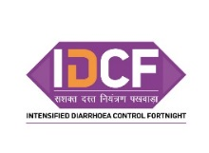

Annexure III: State operational plan - IDCF 2019

(to be filled by State IDCF officer that help him/her to take comprehensive preparations)
State: ______________________ Total under five population of the State: ________________
Nodal Officer of the State: ______________________ Phone No.______________________________
IDCF Secretariat
Names | Designation | Phone No | Responsibility in IDCF

Supply plan for State
District wise (calculated as given in supply requirement)
District | Commodity | Current stock in the district | Supply required by district
A | ORS
A | Zinc
B | ORS
 | Zinc
Total
State compilation
Commodity | Total available Stock in State | Total required by districts
ORS
Zinc

Date of IDCF steering committee meeting: _________________________________________________
State level orientation plan
Venue: ________________________________________________ Date: _________________________
Participants from | Number
Health dept (district & block level)
WCD (district & block level)
IAP/IMA
Development partners
Others

Supply requirement:
Commodities | For distribution by ASHA and mobile teams | For demonstration of ORS and Zinc by ASHA and mobile teams | For ORS – Zinc corners | For treatment by ANM | For treatment by ASHA | For mobile teams | Requirement for IDCF | Current stock in block | To indent
Commodities | A | B | C | D | E | F | G = A + B + C + D + E + F | H | I = G –H
ORS  (formula for calculation) | Under 5 population X 1 packet | No. of VHND sessions X 1 | No. of ORS Zinc corners X 50 cases X 2 | No. of ANM X 10 cases X 2 packets | No. of ASHA X 10 cases X 2 packets | No. of mobile teams X 10 cases X 15 days X 2 packets
ORS (calculate)
Zinc (formula for calculation) |  | No. of VHND sessions X 1 | No. of ORS Zinc corners X 50 cases X 14 | No. of ANM X 10 cases 140 tablets | No. of ASHA X 10 cases 14 tablets | No. of mobile teams X 10 cases X 15 days X 14 tablets
Zinc (calculate)

ORS – Zinc corners plan:
Facilities | Number | Planned ORS – Zinc corners
Medical College (Paeds. OPD)
Medical College (Paeds. ward)
District Hospital (OPD)
District Hospital (ward)
Block CHC / PHC (OPD)
Block CHC / PHC (ward)
Additional PHC (OPD)
Additional PHC (ward)
Sub-center (OPD)
Private clinics (OPD)
Private clinics (ward)
Anganwadis

Printing of treatment protocols
Protocol | Number to be printed
Plan A
Plan B
Plan B – SAM
Plan C
Plan C - SAM

Number of special VHNSD / RI session to be conducted by ANM during IDCF: _____________
IEC plan
Sr. No. | Materials available in district and block | Number required | Number already available | Number to be printed (national materials)
1 | ORS – Zinc poster
2 | Hand-washing poster
3 | Leaflet on ORS – Zinc
4 | Leaflet on breastfeeding
5 | Leaflet on complementary feeding
6 | MCP card

Communication Plan
Sr. No. | Trans-media engagement | Available | Channel/platform | Frequency
1 | TV Spot broadcast plan
2 | Radio spot broadcast plan
3 | Plan using Social Media platforms to enhance outreach
4 | No of street plays, puppet shows etc.

Advocacy and Partnership
Sr. No | Advocacy plan available | Stakeholder | Frequency
1 | Advocacy plan for engaging stakeholders like medical associations, religious leaders, local influencers/social & community groups, youth clubs, NGOs etc.

Printing of formats
Sr. No | Formats | Number
1 | ASHA planning cum tally sheet
2 | Diarrhoea cases line list (ASHA)
3 | Block reporting format
4 | District reporting format
5 | Supportvice supervision format

Mobile team plan
Sr. No. | District | No. of slums / hard-to-reach areas | No. of vehicles / teams

Supportive supervision from State level
Sr. No | Names | Designation | Phone No | District to be visited | Date of visit

Signature of MD – NHM: ________________________

Annexure IV: District operational plan - IDCF 2019

(to be filled by District Health Officer that help him/her to take comprehensive preparations)
District: ______________________Total under five population of the district: ________________
Nodal Officer of the district: ______________________ Phone No.______________________________
IDCF Secretariat
Names | Designation | Phone No | Responsibility in IDCF
Date of IDCF steering committee meeting: _________________________________________________
District level orientation plan
Venue: ________________________________________________ Date: _________________________
Participants from | Number
Health dept (district & block level)
WCD (district & block level)
IAP/IMA
Development partners
Others

Block level orientation plan (Copy and paste as per number of blocks)
Name of block: ______________________ Venue: ________________________Date: _____________
Participants | In position | To be trained
ASHA
ANM
AWW
Staff nurse
MO

Supply requirement:
Commodities | For distribution by ASHA and mobile teams | For demonstration of ORS and Zinc by ASHA and mobile teams | For ORS – Zinc corners | For treatment by ANM | For treatment by ASHA | For mobile teams | Requirement for IDCF | Current stock in block | To indent
Commodities | A | B | C | D | E | F | G = A + B + C + D + E + F | H | I = G –H
ORS  (formula for calculation) | Under 5 population X 1 packet | No. of VHND sessions X 1 | No. of ORS Zinc corners X 50 cases X 2 | No. of ANM X 10 cases X 2 packets | No. of ASHA X 10 cases X 2 packets | No. of mobile teams X 10 cases X 15 days X 2 packets
ORS (calculate)
Zinc (formula for calculation) |  | No. of VHND sessions X 1 | No. of ORS Zinc corners X 50 cases X 14 | No. of ANM X 10 cases 140 tablets | No. of ASHA X 10 cases 14 tablets | No. of mobile teams X 10 cases X 15 days X 14 tablets
Zinc (calculate)

ORS – Zinc corners plan:
Facilities | Number | Planned ORS – Zinc corners | Number of protocols for display
Facilities | Number | Planned ORS – Zinc corners | Plan A | Plan B | Plan B - SAM | Plan C - SAM | Plan C
Medical College (Paeds. OPD)
Medical College (Paeds. ward)
District Hospital (OPD)
District Hospital (ward)
Block CHC / PHC (OPD)
Block CHC / PHC (ward)
Additional PHC (OPD)
Additional PHC (ward)
Sub centre (OPD)

Private clinics (OPD)

Private clinics (ward)
Anganwadis

Printing of treatment protocols
Protocol | Number to be printed
Plan A
Plan B
Plan B – SAM
Plan C
Plan C – SAM

Number of special VHND / RI session to be conducted by ANM during IDCF: _____________
IEC plan
Sr. No. | Materials available in district and block | Number required | Number already available | Number to be printed (national materials)
1 | ORS – Zinc poster
2 | Hand-washing poster
3 | Leaflet on ORS – Zinc
4 | Leaftlet on breastfeeding
5 | Leaflet on complementary feeding

Communication Plan
Sr. No. | Trans-media engagement | Available | Channel/platform | Frequency
1 | TV Spot broadcast plan
2 | Radio spot broadcast plan
3 | Plan using Social Media platforms to enhance outreach
4 | No of street plays, puppet shows etc.

Advocacy and Partnership
Sr. No | Advocacy plan available | Stakeholder | Frequency
1 | Advocacy plan for engaging stakeholders like medical associations, religious leaders, local influencers/social & community groups, youth clubs, NGOs etc.

Printing of formats
Sr. No | Formats | Number
1 | ASHA planning cum tally sheet
2 | Diarrhoea cases line list (ASHA)
3 | Block reporting format
4 | District reporting format
5 | Supportive supervision format

Mobile team plan
Sr. No. | Block | No. of slums / hard-to-reach areas | No. of vehicles / teams

Supportive supervision from district level
Sr. No | Names | Designation | Phone No | Blocks / urban area | Date of visit

Signature of District Collector:__________________________

Annexure V: Block operational plan - IDCF 2019

(to be filled by Block Health officer that help him/her to take comprehensive preparations)
Block: ______________________ Total under five population of the block: ________________
Medical Officer of the block: ______________________ Phone No.______________________________
Block level orientation plan
Venue: ________________________________________________ Date: _________________________
Participants | In position | To be trained
ASHA
ANM
AWW
Staff nurse
MO
Supply requirement:
Commodities | For distribution by ASHA and mobile teams | For demonstration of ORS &Zinc by ASHA & mobile teams | For ORS – Zinc corners | For treatment by ANM | For treatment by ASHA | For mobile teams | Requirement for IDCF | Current stock in block | To indent
Commodities | A | B | C | D | E | F | G = A + B + C + D + E + F | H | I = G –H
ORS  (formula for calculation) | Under 5 population X 1 packet | No. of VHND sessions X 1 | No. of ORS Zinc corners X 50 cases X 2 | No. of ANM X 10 cases X 2 packets | No. of ASHA X 10 cases X 2 packets | No. of mobile teams X 10 cases X 15 days X 2 packets
ORS (calculate)
Zinc (formula for calculation) |  | No. of VHND sessions X 1 | No. of ORS Zinc corners X 50 cases X 14 | No. of ANM X 10 cases 140 tablets | No. of ASHA X 10 cases 14 tablets | No. of mobile teams X 10 cases X 15 days X 14 tablets
Zinc (calculate)

ORS – Zinc corners plan:
Facilities | Number | Planned ORS – Zinc corners | Number of protocols for display
Facilities | Number | Planned ORS – Zinc corners | Plan A | Plan B | Plan B – SAM | Plan C | Plan C - SAM
Block CHC / PHC (OPD)
Block CHC / PHC (ward)
Additional PHC (OPD)
Additional PHC (ward)
Subcenter (OPD)

Private clinics (OPD)

Private clinics (ward)
Anganwadis

Number of special VHND / RI session conducted by ANM during IDCF where importance on diarrhoea control to be emphasised: ………………..
IEC plan
Sr. No. | Materials available in district and block | Number required | Number already available | Number to be printed (national materials)
1 | ORS – Zinc poster
2 | Hand-washing poster
3 | Leaflet on ORS – Zinc
4 | Leaftlet on breastfeeding
5 | Leaflet on complementary feeding
6 | MCP card

Communication Plan
Sr. No. | Trans-media engagement | Available | Channel/platform | Frequency
1 | No of street plays, puppet shows etc.

Advocacy and Partnership
Sr. No | Advocacy plan available | Stakeholder | Frequency
1 | Advocacy plan for engaging stakeholders like medical associations, religious leaders, local influencers/social & community groups, youth clubs, NGOs etc.

Requirement of formats
Sr. No | Formats | Number
1 | ASHA planning cum tally sheet
2 | Diarrhoea cases line list (ASHA)
3 | Block reporting format
4 | District reporting format
5 | Supportive supervision format

Mobile team plan
Sr. No. | Name of slum or hard-to reach area | No. of vehicles / teams | Name of team members | Date of visit

Supportive supervision from block level
Sr. No | Names | Designation | Phone No | Village / slum / hard – to- reach | Date of visit

Signature of Block Medical Officer:__________________________

Annexure VI: Village level plan for IDCF and implementation checklist
(For ANM)

(MOIC to ensure this format is filled for all sub-centres including vacant sub-centres)
Name of the sub-centre:___________ Block: ___________ Name & Mobile no of ANM:__________
ANM visit plan during IDCF
 | 28 May | 29 May | 30 May | 31 May | 1 June | 2 June | 3 June
Village/ urban area
VHND village (as per routine microplan) (Write Yes /No)
No. of under 5 children in the village
Name of ASHA and mobile no
 | 4 June | 5 June | 6 June | 7 June | 8 June | 9 June
Sub Centre
VHND village (as per routine microplan) (Write Yes /No)
No. of under 5 children in the village
Name of ASHA and mobile no

List of vulnerable area to be covered (nomadic/tribal/brick kiln, tea garden etc)
1
2
3
4

Annexure VII: Village level plan cum monitoring format for IDCF and implementation checklist
(For ASHA)
District: __________Block:__________Village: _____________Total population:___________Families with under 5 children: _____
ASHA:__________________________________ Mob. No. :________________ Total under five children: ___________
Listing of children (to be done before the campaign by 17 May) |  |  |  |  |  |  | Home visit (28May–8 June) to be filled during the campaign
Sr. No | Father name | Mother name | Child detail |  |  |  | Date of visit | Distribution of  ORSwith demonstration  ( if yes) | Does the child suffer from diarrhoea  ( if yes) | ORS &Zinc given to the child with diarrhoea  ( if yes) | Whether danger sign and referred  ( if yes)
Sr. No | Father name | Mother name | Name | Age | Gender ( wherever applicable)
 |  |  |  |  | M | F
Total

Signature of ASHA: ____________ ____________ SIgnature of ANM:__________________________

Annexure VIII: Mobile team plan and reportingfor IDCF

Name of block / municipal area: __________________________Name of Medical Officer I/c of IDCF:________________________ Mobile No.: _________________

Plan |  |  |  |  |  |  | Actuals
Team No | Name of team members | Vehicle No | Mobile No. | Date of planned visit | Place of visit* | Estimated under 5 children in the place | Date of visit | No. of children distributed ORS | No of children treated with ORS | No of children treated with Zinc

*The places of visit should be urban slums, underserved and hard to reach populations (forested and tribal populations, hilly areas etc.), flood prone areas, migrant settlements (fisherman villages, riverine areas with shifting populations, refugees), nomadic sites, brick kilns, construction sites, orphanage, temporary shelters and street children

Signature of Medical Officer I/c of IDCF: ________________________________________

Annexure IX: Sub-centre reporting format

District: ____________ Block:_____________ Subcenter: _____________________
ANM Name:__________________________________ Mob. No. :________________

Sr. No. |  | Number
1 | Total No. of villages
2 | No of villages where ORS was distributed
3 | No. of under five children in the villages
4 | No. of children distributed with ORS
5 | No. of children reported with Diarrhoea during IDCF
6 | No. of children with Diarrhoea provided with ORS
7 | No. of children with Diarrhoea provided Zinc for 14 days
8 | No. of children detected with Danger signs and referred by ASHA
9 | No. of villages where VHNSC session on sanitation was conducted
10 | Whether ORS – Zinc corner established at subcenter (Yes / No)
11 | No. of schools where handwashing demonstration was carried out
12 | Whether Plan A displayed in subcentre (Yes / No)
13 | Whether Plan B displayed in subcentre (Yes / No)
14 | Whether Plan B– SAM displayed in subcentre (Yes / No)

Signature of ANM: ______________________________

AnnexureX: Block reporting format

Block:_____________ Name of BMO:____________________________
Sr. No. |  | Number
1 | Total No. of villages
2 | No of villages where ORS was distributed
3 | No. of under five children in the villages
4 | No. of children distributed with ORS
5 | No. of children reported with Diarrhoea during IDCF
6 | No. of children with Diarrhoea provided with ORS
7 | No. of children with Diarrhoea provided Zinc for 14 days
8 | No. of children detected with Danger signs and referred by ASHA
9 | No. of villages where VHNSC session on sanitation was conducted
10 | No. of ORS – Zinc corner established (including block level)
11 | No. of ORS – Zinc corner established in private medical practitioners
12 | No. of schools where handwashing demonstrated
13 | Number of health facilities where Plan A was displayed
14 | Number of health facilities where Plan B was displayed
15 | Number of health facilities where Plan B – SAM was displayed
16 | Number of health facilities where Plan C was displayed
17 | Number of health facilities where Plan C – SAM was displayed
18 | No. of slums / hard-to-reach areas
Performance of Mobile teams
19 | No. of mobile teams formed
20 | No. of children received ORS from mobile teams
21 | No. of children with Diarrhoea provided with ORS
22 | No. of children with Diarrhoea provided Zinc for 14 days
23 | No. of one day orientation meeting conducted at PHC
24 | No. of one day orientation meeting held at block level

Signature of BMO: __________________________________

Annexure XI: District and State reporting format

1 | Name of District / State:
2 | Name of Nodal Officer Implementing IDCF  Email:  Phone: | ………….  ………….  …………...
3 | No. of Districts conducted IDCF 2019/Total No. of Districts | …../…….
4 | State launch undertaken as per guidelines (Yes/No)
5 | No. of Districts where District launch was undertaken
6 | No. of ASHAs oriented on IDCF/ No. of ASHA in district / State | .…../……..
7 | No. of ANMs oriented on IDCF/ No. of ANMs in district / State | ……/……
 | No. of MO’s oriented on IDCF / No. of MOs in district / State | ……/……
8 | No. of Staff Nurses oriented on Diarrhoea management/ No. of Staff Nurses in district / State | ……/……
9 | Dates of IDCF observation:
10 | No. of vehicles hired for field supportive supervision
11 | No. of HPDs and aspirational districts where supportive supervision was undertaken by Development Partners /Total no. of HPDs and aspirational districts | …../…….
12 | Total No. of villagesin district / State
13 | No of villages where ORS was distributed
14 | No. of under five children in the villages
15 | No. of children distributed with ORS
16 | No. of children reported with Diarrhoea during IDCF
17 | No. of children with Diarrhoea provided with ORS
18 | No. of children with diarrhoea provided Zinc for 14 days
19 | No. of children detected with danger signs and referred by ASHA
20 | No. of villages where VHNSC session on sanitation was conducted
21 | No. of ORS – Zinc corner established (including block / district level)
22 | No. of ORS – Zinc corner established in private medical practitioners
23 | No. of schools where hand-washing demonstrated
24 | Number of health facilities where Plan A was displayed
25 | Number of health facilities where Plan B was displayed
26 | Number of health facilities where Plan B – SAM was displayed
27 | Number of health facilities where Plan C was displayed
28 | Number of health facilities where Plan C – SAM was displayed
Performance of Mobile Teams
29 | No. of slums / hard-to-reach areas
30 | No. of mobile teams formed
31 | No. of children received ORS from mobile teams
32 | No. of children with Diarrhoea provided with ORS
33 | No. of children with Diarrhoea provided Zinc for 14 days
34 | No. of one day orientation meeting conducted at PHC
35 | No. of one day orientation meeting held at block level
36 | No. of one day orientation meeting held at district level

Signature of Child Health Nodal Officer_______________________________________

Annexure XII: District level Supportive Supervision Checklist
For State level monitors
Name of monitor:____________Designation:__________Organization: __________Mob. No: ______
Name of district:______________________________ Date of visit: _______________________
Planning at district level (Monitor should meet DM, CMO, RCHO and other district level officers)
Name of CMO/RCHO/ District Nodal Person for IDCF and mobile nos.:
IDCF Steering Committee meeting held with Chair by DM (verify minutes) |  |  | District operational plan available
Yes No Committee not formed |  |  | Yes No
District level orientation on IDCF held |  |  |  | Yes No
Participants / departments in district orientation on IDCF (circle applicable after verification of minutes of meeting) |  |  | H&FW (BMO / Municipal MO / BCM) / WCD / PRI / Water and Sanitation / Tribal Welfare / Education / District IEC
Assessment of requirement of ORS and Zinc done by district officials |  |  |  | Yes No
If shortfall of ORS then, procurement of ORS done / supply received from state level Yes No NA |  |  | If shortfall of Zinc then, procurement of Zinc done / supply received from state level Yes No NA
Availability and supply ensured of (circle applicable) |  |  | MCP card / MUAC tape / Weighing machine
District received communication regarding IDCF from State HQ |  |  |  | Yes No
District issued communication regarding IDCF to block |  |  |  | Yes No
District launch of IDCF by prominent person |  |  |  | Yes No
Financial norms for IDCF
District has clarity on financial norms for ASHA incentives for IDCF |  |  |  | Yes No
District received funds for IDCF |  |  |  | Yes No
IEC planning
IEC material on IDCF e. g Banner, Posters, audio video clippings received from state: Yes No District produced

IEC material on IDCF distributed to blocks |  |  |  | Yes No
Supportive supervision
District supportive supervision plan is in place with clear role and logistic arrangement |  |  |  | Yes No
Supportive supervision formats printed and given to blocks |  |  |  | Yes No
Review mechanism of implementation of IDCF from district level (circle applicable) |  | Daily evening meeting of supervisors with CMO / Daily phone communication with supervisors / review meeting after week
Implementation plan (verify)
No. of blocks in the district |  |  | No. of urban areas in the district
No. of blocks submitted microplan |  |  | No. of urban areas submitted microplan
No. of blocks that have constituted mobile team for IDCF |  |  | No. of urban areas that have constituted mobile team for IDCF
District officials of WCD & Education dept. have instructed blocks, AWCs, Schools to participate in IDCF campaign (verify communication) |  |  |  | Yes No
Signature_____

Annexure XIII: Block / urban level Supportive Supervision Checklist
(For State and District level monitors)
Name of monitor:_______________________________Designation:___________________________
Organization:__________________________________Mob. No: _____________________________
Name of state: _________________Name of district:_______________
Name of block / urban area:_________________ Date of visit: ________
Planning at block / urban level
Name of BMO / Municipal MO and mobile no.:
BMO / Municipal MO attended the district level steering committee meeting on IDCF |  |  |  | Yes No
Block / urban area level filled operational plan available |  |  |  | Yes No
ASHA level filled listing of under children available for all villages |  |  |  | Yes No
Block level filled VHNSC plan available for all villages |  |  |  | Yes No
Block reporting format available |  |  |  | Yes No
Sub-center reporting formats distributed to all sub-centers |  |  |  | Yes No
Funds for ASHA incentives received |  |  |  | Yes No
ORS – Zinc corner (prioritize visit to Medical College, District Hospital, Children Hospital, Block Hospital)
Established in OPD area |  |  |  | Yes No
ORS available |  |  |  | Yes No
Zinc available |  |  |  | Yes No
Drinking water available |  |  |  | Yes No
All the corner staff trained on diarrhoea management within last 1 month |  |  |  | Yes No
Plan A treatment protocol displayed |  |  |  | Yes No
Plan B treatment protocol displayed |  |  |  | Yes No
Plan B - SAM treatment protocol displayed |  |  |  | Yes No
ORS – Zinc poster displayed |  |  |  | Yes No
Established in ward |  |  |  | Yes No
ORS available |  |  |  | Yes No
Zinc available |  |  |  | Yes No
Drinking water available |  |  |  | Yes No
All MO & nurses of ward trained on diarrhoea management within last 1 month |  |  |  | Yes No
Plan A treatment protocol displayed |  |  |  | Yes No
Plan B treatment protocol displayed |  |  |  | Yes No
Plan B - SAM treatment protocol displayed |  |  |  | Yes No
Plan C treatment protocol displayed in ward |  |  |  | Yes No
Plan C – SAM treatment protocol displayed in ward |  |  |  | Yes No
ORS – Zinc poster displayed |  |  |  | Yes No
Last case of diarrhoea was prescribed Zinc during discharge (verify record) |  |  |  | Yes No
Mobile team
Mobile teams required for the block |  |  |  | Yes No
Mobile teams constituted |  |  |  | Yes No
Mobile teams have visited slums / orphanages / migrant population / HTRAs (verify record) |  |  |  | Yes No
Supportive supervision
District monitor has visited the block for monitoring |  |  |  | Yes No
Supportive supervision plan available |  |  |  | Yes No
Supervisors visiting as per plan |  |  |  | Yes No
Visit villages where VHNSC meeting is planned on day of supportive supervision | Village 1 | Village 2 | Village 3 | Village 4
Name of village visited
VHNSC meeting held on sanitation | Yes No  Y | Yes No | Yes No | Yes No
Name of ASHA and mobile no.

ASHA trained on her role in IDCF within last 1 month | Yes No | Yes No | Yes No | Yes No
ORS – Zinc distribution by ASHA / ANM is as per plan | Yes No  Y | Yes No | Yes No | Yes No
ASHA used the IDCF leaflet during counselling of mothers
No. of houses with under 5 children visited by monitor (at least 3 houses where ASHA has already visited)
Of the above, no. of houses where ORS was distributed by ASHA
No. of houses (respondents) who saw any of the following:
Poster
Hoarding
TV commercial
Radio spot
No. of houses (respondents) who know what to do if their child has diarrhoea
(seek health advise from ASHA/ AWW, ORS + Zinc)
No. of houses (respondents) who know where to get ORS and Zinc from (Health centres, ASHAs/ ANM)
No. of houses (respondents) who know what can they do to prevent diarrhoea(hand wash, disposal of feces)
 | School 1 | School 2 | School 3 | School 4
Name of school visited
After morning assembly / prayers, importance of hand washing is communicated to students. | Yes No | Yes No | Yes No | Yes No
Poster on hand-washing pasted at the hand washing area | Yes No | Yes No | Yes No | Yes No
Before mid-day-meal, all children taught to wash hands | Yes No | Yes No | Yes No | Yes No
School activities conducted around hygiene and sanitation | Yes No | Yes No | Yes No | Yes No
Supportive supervision
District monitor has visited the block for monitoring |  |  |  | Yes No
Supportive supervision plan available |  |  |  | Yes No
Supervisors visiting as per plan |  |  |  | Yes No

Signature_______________

Annexure XIV: Village level Supportive Supervision Checklist
(Block level monitors)
Name of supervisor:_______________Designation:_______________________Mob. No: __________
Name of district:__________Name of block: _________________ Date of visit: __________________
Visit villages where VHNSC meeting is planned on day of supportive supervision | Village 1 | Village 2 | Village 3 | Village 4
Name of village visited
VHNSC meeting on sanitation held | Yes No  Y | Yes No  Y | Yes No  Y | Yes No  Y
Name of ASHA and mobile no.
ASHA trained on her role in IDCF within last 1 month | Yes No  Y | Yes No  Y | Yes No  Y | Yes No  Y
Knows the activities to be done in IDCF [(1) Distribution of one ORS packet to each mother/care giver having children under 5 years (2) Treat child with diarrhoea having no danger signs (3) Counsel Mothers/Care givers on feeding practices (4) Refer Child to facility in case child detected with danger signs during diarrhoea] | Yes No  Y | Yes No  Y | Yes No  Y | Yes No  Y
Listing of children as per format available with ASHA | Yes No  Y | Yes No  Y | Yes No  Y | Yes No  Y
Knows definition of diarrhoea[when the stools have changed from usual pattern and are many and watery (more water than fecal matter}] | Yes No  Y | Yes No  Y | Yes No  Y | Yes No  Y
Knows the danger signs of dehydration  [Any two of the following for some dehydration eg. Restless/Irritable, Sunken Eyes, Drinking eagerly/Thirsty & Skin Pinch goes back slowly  and any two of the following for Severe Dehydration eg. Lethargic or unconscious, Sunken eyes, Not able to drink or drinking poorly & skin pinch goes back very slowly (more than 2 seconds)] | Yes No  Y | Yes No  Y | Yes No  Y | Yes No  Y
Knows referral to facility in case of danger signs of diarrhoea[as per above danger signs] | Yes No  Y | Yes No  Y | Yes No  Y | Yes No  Y
Knows correctly the treatment of diarrhoea if the child has no danger signs [(1) Give Extra Fluids/ORS (2) Give Oral Zinc Tablets (3) Continue Feeding (4) Advise Mother when to return –Child becomes sicker/not able to drink or breast feed/blood in stool/drinking poorly/develops fever] | Yes No  Y | Yes No  Y | Yes No  Y | Yes No  Y
Knows correctly how to prepare ORS [assessment based on demonstration of preparation of ORS] | Yes No  Y | Yes No  Y | Yes No  Y | Yes No  Y
Knows correctly the doses of Zinc [2-6 months-10 mg. and 6 months to 5 years- 20 mg] | Yes No  Y | Yes No  Y | Yes No  Y | Yes No  Y
Knows how to administer Zinc [to be dissolved in breast milk/ plain water] | Yes No  Y | Yes No  Y | Yes No  Y | Yes No  Y
ORS – Zinc distribution by ASHA is as per plan | Yes No  Y | Yes No  Y | Yes No  Y | Yes No  Y
No. of houses with under 5 children visited by monitor [atleast 3 houses where ASHA has already visited]
Of the above, no. of houses where ORS was distributed by ASHA
No. of houses (respondents) who saw any poster/ hoarding, TV commercial or radio spot on diarrhoea during the IDCF
No. of houses (respondents) who known what to do if their child has diarrhoea (seek health advise from ASHA/ AWW, ORS + Zinc)
No. of houses (respondents) who know where to get ORS and Zinc from (Health centers, ASHAs/ ANM)
No. of houses (respondents) who know what can they do to prevent diarrhoea(hand wash, disposal of feces)
 | School 1 | School 2 | School 3 | School 4
Name of school visited
After morning assembly / prayers, importance of hand washing is communicated to students. | Yes No  Y | Yes No  Y | Yes No  Y | Yes No  Y
Poster on hand-washing pasted at the hand washing area | Yes No  Y | Yes No  Y | Yes No  Y | Yes No  Y
Before mid-day-meal, all children taught to wash hands | Yes No  Y | Yes No  Y | Yes No  Y | Yes No  Y
School activities conducted around hygiene and sanitation

Signature:____________________

Annexure XV: Set up of ORS – ZINC CORNER

ORS - Zinc Corners are usually meant for diarrhoea with some dehydration to be administered ORS under supervision for 4 hours. Also these corners serve the purpose of counselling for caregivers for children with no-dehydration and initiating their treatment. .

Location:

ORS – Zinc corners should be established athealth facilities like Medical Colleges, District Hospitals, Block health facilities, Primary Health Centres, Sub-Centres, Private Paediatrics facilities etc. Earmark a suitable area in the health facility for the corner. A small corner in the OPD or ward or any other suitable area in the health facility is generally enough for this purpose. The space required would depend on the case load. While earmarking such an area it should be ensured that:

- In case of hospital, the area should be close to the nursing station or the workplace of the Doctor so that assessment of the child can be carried out frequently.
- The area should have easy access to a toilet and washing facility, where mothers can clean the child and wash their hands before feeding them.
- Area should have seating arrangements to enable mothers to sit comfortably while administering ORS to their child.
- Pleasant and well-ventilated.

Timings:

The ORS – Zinc corners should be functional during OPD timings and 24 hours in paediatrics ward. A health worker who is trained in preparation of ORS solution and Zinc solution, should be posted to manage the corner. The corner should be prominently labelled as “ORS – Zinc Corner for treatment of diarrhoea”

Materials required for management of ORS – Zinc corner
- One table where sufficient ORS packets and Zinc tablets with potable drinking water in a clean container, five glasses (200 ml), bowl / cup, soap, waste-bucket, one litre vessel, clean spoons, MCP cards and leaflets are placed..
- One chair for the health worker
- Two chairs or one bench with a back where the mother can sit comfortably while holding the child
- Shelves to hold supplies

Counselling at the ORS – Zinc corners:
- The doctor / health staff should counsel the mother in person using MCP card on use of ORS and Zinc.
- ORS – Zinc corner is a good place to display informative materials. Banner and poster on ORS – Zinc, hand washing and continued feeding should be displayed at the corner.

Activities:
- At least one litre of ORS solution should be prepared daily after washing hands with soap and water. It should be readily available to the mother when required. Replenish the solution whenever required. Discard the prepared solution after 24 hours of preparation. After the mother has washed her hands thoroughly with soap and water, provide the ORS solution in bowl / cup or glass with spoon to enable her to administer the solution.

- If there is a diarrheal episode during ORS administration, then the child, mother and the area should be thoroughly cleaned. After washing hands again with soap and water the mother should administer ORS.

- If the child vomits, while administering ORS, then clean the child and area, and the mother should re-administer ORS slowly, after washing hands again with soap and water.

- In case of diarrhoea with no-dehydration,
  - Administer ORS solution at the corner for some time till the child is comfortable.
  - Explain the mother on how to prepare the ORS solution, if possible demonstrate.
  - Demonstrate on how to prepare age appropriate Zinc tablet solution in a spoon.
  - Administer the first dose of Zinc tablet solution.
  - Explain when to administer ORS and Zinc.
  - Provide at least one ORS packet and 13 tablets of Zinc to take home.
  - Advice on age appropriate feeding during diarrhoea
  - Advice when to return

- In case of diarrhoea with some-dehydration,
  - Check whether the child has severe acute malnutrition
  - Administer ORS solution at the corner for 4 hours (5 ml / kg / hr for SAM)
  - Re-assess the child for status of dehydration.
  - If child has no dehydration, follow the steps of Plan A
  - If child’has severe-dehydration, the child needs to be admitted for Plan C treatment.

Annexure XVI: Mother and Child Protection Card – Diarrhoea prevention and treatment section
Front page of MCP card Diarrhoea – prevention and section on page number 9 of the MCP card
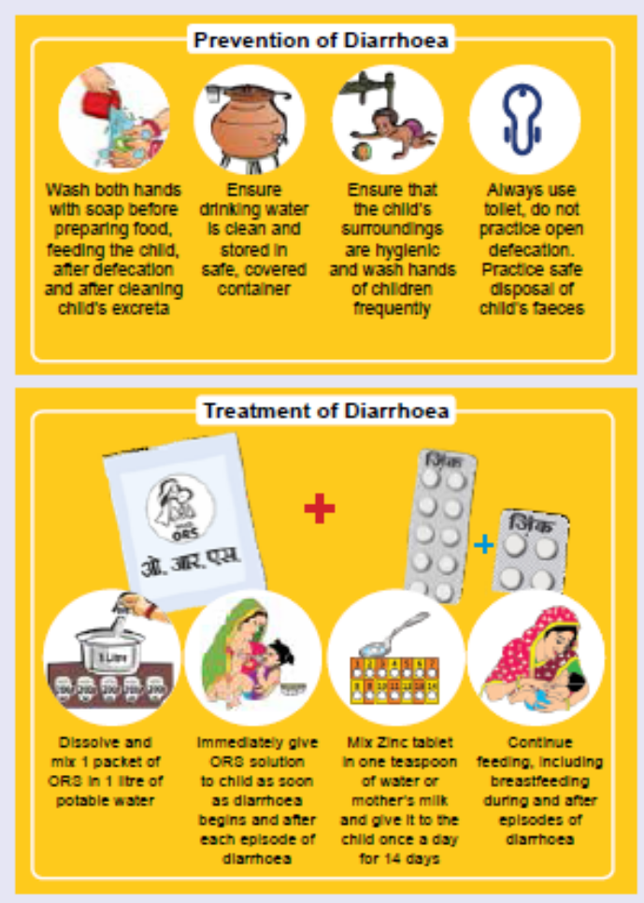
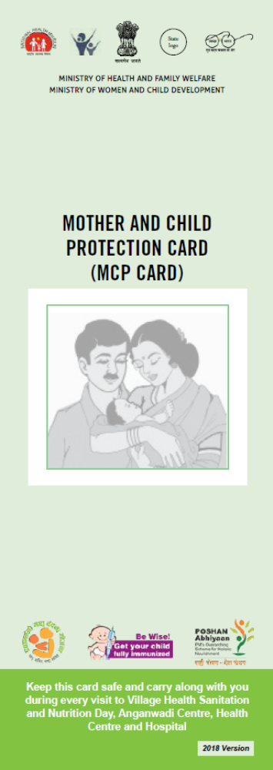

Annexure XVII: Content for VHSNC meeting to be conducted during IDCF.

ANM should carry out IDCF meeting with VHSNC members in her subcentre village and those villages where her VHND workplan falls in the IDCF. ASHA will mobilize all families with under-five children as well as VHSNC members for the session.
- ANM should start the session with key message of the IDCF campaign highlighting importance of ORS and Zinc, hand-washing and importance of Sanitation & hygiene in control of childhood diarrhoea. MCP card should be used or this purpose.

a. After highlighting importance of hygiene and sanitation, ANM and or ASHA should demonstrate hand-washing with soap and water.

b. ANM should demonstrate preparation of ORS and Zinc, importance of safe water, hand-washing.

c. ANM should communicate on danger signs of diarrhoea (using the IDCF Toolkit).

d. ASHA should distribute ORS to each family with under-five child who are present during the session.

e. If there are cases of diarrhoea then ANM or ASHA should assess the child and provide ORS – Zinc. If child is severely dehydrated then referral should be ensured.

2. PLA (Participatory Learning Approach) technique to be used for advocacy around sanitation & hygiene: PLA techniques can include mapping of open defecation areas in and surrounding the village and plan for stopping open defecation, with active participation of VHSNC members and representatives from Department of Drinking Water and Sanitation.
2.1 The ASHA / ANM will ask the participants to narrate the ailments caused due to water contamination. This could be Diarrhoea, Typhoid, Intestinal worms, Abdominal pain, Vomiting etc.

2.2 The ASHA / ANM will ask participants to say what contaminates the water and food to cause these diseases. A relationship between human faeces, water and the diseases will be established. Focus on how faecal matter slowly recedes into the soil. She will explain how contaminated human faeces get into water and food from open defecation through flies.

F – Diagram on transmission of diarrhoeal infection
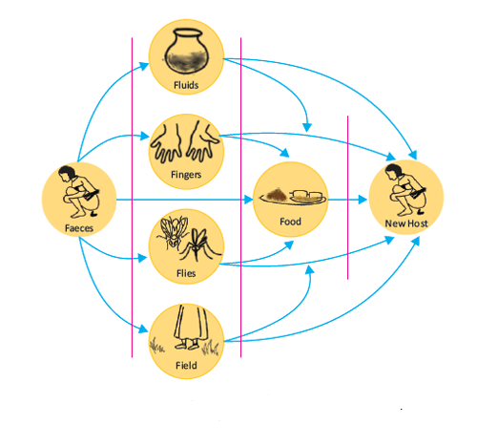

2.3 The ASHA / ANM will ask one of the participants who had suffered from Diarrhoea, about the suffering and cost involved for treatment.

2.4 A calculation of quantity of faeces will be done. For this the ASHA / ANM will ask the participants the average percentage of households that do not have a toilet.
- Average percentage of households that do not have toilet X Total population of the village = No. of people defecating in the open.

• No. of people defecating in the open. X 0.3 kg (average faeces excreted per person per day) = Daily quantity of faeces excreted in open (in kg).

• Daily quantity of faeces excreted X 30 days = Monthly quantity of faeces excreted in open (in kg).

• Monthly quantity of faeces excreted per day X 12 months = Annual quantity of faeces excreted in open (in kg).

2.5 The importance of use of toilet for defecation will be emphasised.

2.6 A rough map of the village will be drawn on the ground using a stick or stone.

2.7 Geographical areas within the village and it’s vicinity that are used for open defecation (i.e. toilets not used for defecation) will be marked in the map. She will explain how contaminated human faeces get into water and food from open defecation through flies.

2.8 A plan will be made / updated on construction of toilets in the households of the village.

3. For the above exercise, ASHA may test water from it’s source using the field test kit (H2S vials) that is with the gram panchayats. The result of the test is available in 24 hours. The result can be declared during the above exercise.

Annexure XVIII: Names of 117 aspirational districts
S. No. | Name of State | Total Aspirational Districts | Name of Aspirational Districts for Rapid Transformation
1 | Andhra Pradesh | 3 | Visakhapatnam
1 | Andhra Pradesh | 3 | Y.S.R.(Cuddapah)
1 | Andhra Pradesh | 3 | Vizianagaram
2 | Arunachal Pradesh | 1 | Namsai
3 | Assam | 7 | Darrang
3 | Assam | 7 | Dhubri
3 | Assam | 7 | Barpeta
3 | Assam | 7 | Goalpara
3 | Assam | 7 | Baksa
3 | Assam | 7 | Udalgiri
3 | Assam | 7 | Hailakandi
4 | Bihar | 13 | Katihar
4 | Bihar | 13 | Begusarai
4 | Bihar | 13 | Sheikhpura
4 | Bihar | 13 | Araria
4 | Bihar | 13 | Sitamarhi
4 | Bihar | 13 | Khagaria
4 | Bihar | 13 | Purnia
4 | Bihar | 13 | Aurangabad
4 | Bihar | 13 | Banka
4 | Bihar | 13 | Gaya
4 | Bihar | 13 | Jamui
4 | Bihar | 13 | Muzaffapur
4 | Bihar | 13 | Nawada
5 | Chhattisgarh | 10 | Korba
5 | Chhattisgarh | 10 | Mahasamund
5 | Chhattisgarh | 10 | Bastar
5 | Chhattisgarh | 10 | Bijapur
5 | Chhattisgarh | 10 | Dantewada
5 | Chhattisgarh | 10 | Kanker
5 | Chhattisgarh | 10 | Kondagaon
5 | Chhattisgarh | 10 | Narayanpur
5 | Chhattisgarh | 10 | Rajnandgaon
5 | Chhattisgarh | 10 | Sukma
6 | Gujarat | 2 | Narmada
6 | Gujarat | 2 | Dahod
7 | Haryana | 1 | Mewat
8 | Himachal Pradesh | 1 | Chamba
9 | Jammu & Kashmir | 2 | Kupwara
9 | Jammu & Kashmir | 2 | Baramula
10 | Jharkhand | 19 | Sahebganj
10 | Jharkhand | 19 | Pakur
10 | Jharkhand | 19 | Godda
10 | Jharkhand | 19 | Latehar
10 | Jharkhand | 19 | Lohardaga
10 | Jharkhand | 19 | Palamu
10 | Jharkhand | 19 | Purbi Singhbhum
10 | Jharkhand | 19 | Ramgarh
10 | Jharkhand | 19 | Ranchi
10 | Jharkhand | 19 | Simdega
10 | Jharkhand | 19 | West Singhbhum
10 | Jharkhand | 19 | Bokaro
10 | Jharkhand | 19 | Chatra
10 | Jharkhand | 19 | Dumka
10 | Jharkhand | 19 | Garhwa
10 | Jharkhand | 19 | Giridh
10 | Jharkhand | 19 | Gumla
10 | Jharkhand | 19 | Hazaribagh
10 | Jharkhand | 19 | Khunti
11 | Karnataka | 2 | Yadgir
11 | Karnataka | 2 | Raichur
12 | Kerala | 1 | Wayanad
13 | Madhya Pradesh | 8 | Damoh
13 | Madhya Pradesh | 8 | Singrauli
13 | Madhya Pradesh | 8 | Barwani
13 | Madhya Pradesh | 8 | Vidisha
13 | Madhya Pradesh | 8 | Khandwa
13 | Madhya Pradesh | 8 | Chhatarpur
13 | Madhya Pradesh | 8 | Rajgarh
13 | Madhya Pradesh | 8 | Guna
14 | Maharashtra | 4 | Nandurbar
14 | Maharashtra | 4 | Washim
14 | Maharashtra | 4 | Osmanabad
14 | Maharashtra | 4 | Gadchiroli
15 | Manipur | 1 | Chandel
16 | Meghalaya | 1 | Ribhoi
17 | Mizoram | 1 | Mamit
18 | Nagaland | 1 | Kiphire
19 | Odisha | 10 | Rayagada
19 | Odisha | 10 | Kalahandi
19 | Odisha | 10 | Kandhamal
19 | Odisha | 10 | Gajapati
19 | Odisha | 10 | Dhenkanal
19 | Odisha | 10 | Balangir
19 | Odisha | 10 | Koraput
19 | Odisha | 10 | Malkangiri
19 | Odisha | 10 | Naupada
19 | Odisha | 10 | Nabarangpur
20 | Punjab | 2 | Firozpur
20 | Punjab | 2 | Moga
21 | Rajasthan | 5 | Baran
21 | Rajasthan | 5 | Jaisalmer
21 | Rajasthan | 5 | Dholpur
21 | Rajasthan | 5 | Karauli
21 | Rajasthan | 5 | Sirohi
22 | Sikkim | 1 | West Sikkim
23 | Tamil Nadu | 2 | Ramanathapuram
23 | Tamil Nadu | 2 | Virudhunagar
24 | Telangana | 3 | Bhoopalpalli
24 | Telangana | 3 | Asifabad
24 | Telangana | 3 | Khammam
25 | Tripura | 1 | Dhalai
26 | Uttar Pradesh | 8 | Chitrakoot
26 | Uttar Pradesh | 8 | Balrampur
26 | Uttar Pradesh | 8 | Bharaich
26 | Uttar Pradesh | 8 | Sonbhadra
26 | Uttar Pradesh | 8 | Chandauli
26 | Uttar Pradesh | 8 | Siddharthnagar
26 | Uttar Pradesh | 8 | Fatehpur
26 | Uttar Pradesh | 8 | Shrawasti
27 | Uttarakhand | 2 | Haridwar
27 | Uttarakhand | 2 | Udham Singh Nagar
28 | West Bengal | 5 | Murshidabad
28 | West Bengal | 5 | Maldah
28 | West Bengal | 5 | Birbhum
28 | West Bengal | 5 | Nadia
28 | West Bengal | 5 | Dakshin Dinajpur

Annexure XIX: ORS and Zinc co-packet specification.

Each co-packet should have 2 packets of ORS and 14 tablets of Zinc
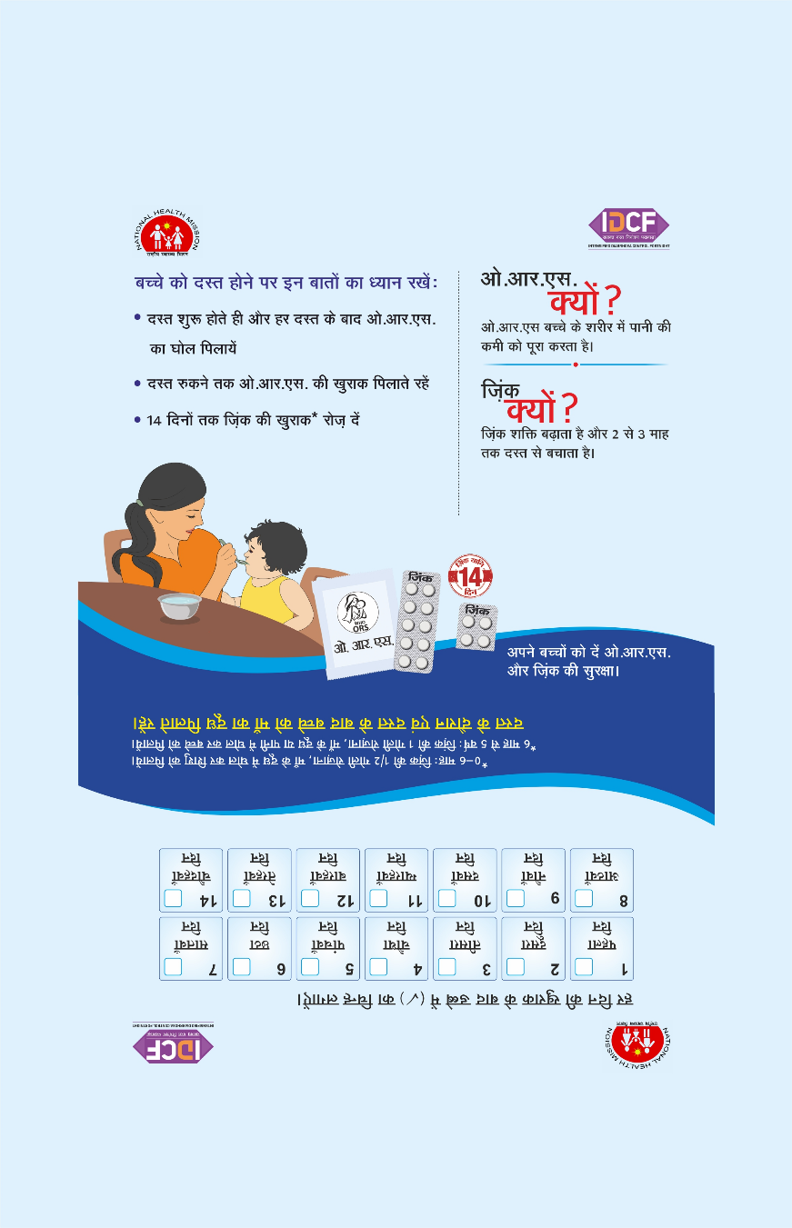

Paper : 170 gsm imp. art paper
Size : 5.9" x 4.9" (Close size )
Fabrication : Thermal gloss lamination on both side with double tape pasting and strip gumming on flap

Annexure XX: ORS and Zinc corner’s canopy.

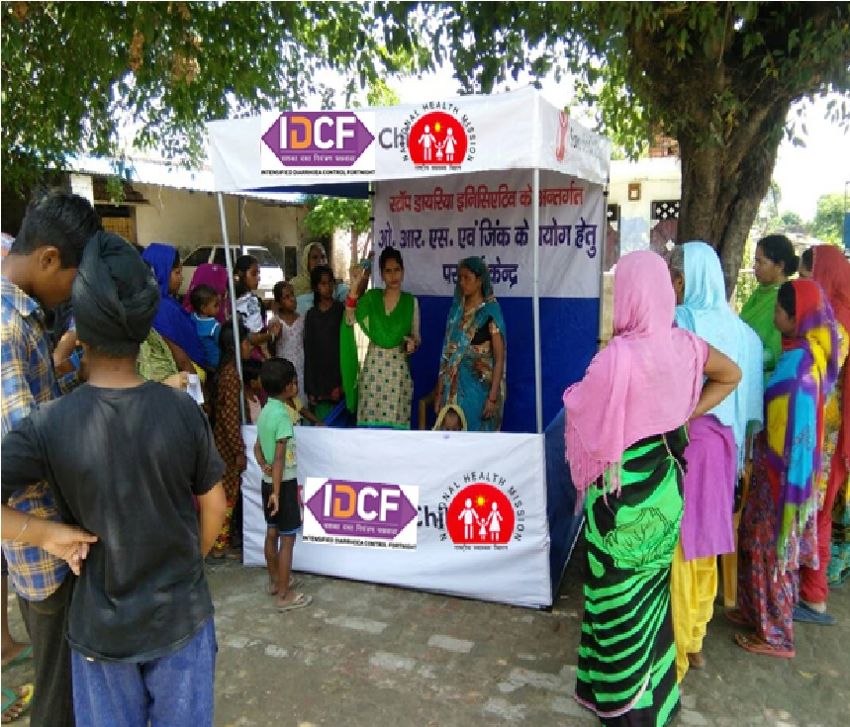

- Size
Length: 6 feet
Breadth: 6 feet
Height: 7 feet

- Dimension for flex background banner: Length: 6 feet and Breadth: 4 feet
- For square corners of the roof: 6 by 1.5 ( 3 sq corners for front and side roof skirting)
- For front knee side banner for 3 square corner: 6 by 2.5 feet with 12 Rods (structure)
- Printing: star printing (Flex) for banners

IDCF Toolkit
Contents:
- Orientation module
- Communication Kit for Awareness campaign
(IDCF toolkit is a separate document provided with these guidelines)
IDCF Secretariat
In case of any further information may contact:
- Dr. Ajay Khera, Deputy Commissioner (Child Health & Immunization)
Email: ajaykheramch@gmail.com
Telefax: 011-23061281
- Dr. Sila Deb, Deputy Commissioner (Child Health)
Email: drsiladeb@gmail.com
Telefax: 01123061218
- Vishal Kataria, Lead Consultant – M & E (Child Health)
Email: idcfsecretariat@gmail.com
Mobile: +91-9716762894

Sample registration survey
Rural Development Department, Civil Surgeon, District Immunization Officer, Regional Programme Manager, District Programme Manager. District Community Manager, District Surveillance Officer, Project Officer - ICDS
Block Programme Officer, Medical Officer Block Community Manager, Block Community Project Manager, Block Health Manager

